
Assessment Cover Sheet

Due Date
15-Dec-2025

Course Code
IT7009
Assessment Title
Project _Group

Course Title
Artificial Intelligence

Internal Moderator’s Name
Mahmoud Alhamad

External Examiner’s Name

Not must-pass
Individual
Uncontrolled
Assessment Type

Instructions:
- This cover sheet must be completed (section in blue below) and attached to your assessment before submission in soft copy.
- The deadline for this assessment is 15-Dec-2025 (11:55 PM).
- This assessment carries 35% marks assessing CILO 1, CILO2, and CILO 3.
- Late submission, marks will be capped at 60%. Two calendar days after the deadline, students will get 0%.
- References consulted (if any) must be properly acknowledged and cited.

Programme Title
Learner ID
202201250-202201735-202300436-202304613-202303439-202302024
Date Submitted
30/12/2025
Learner Name
Artificial Intelligence

IT7009

Mohammed Alasfoor – Redha Mossa - Abdulelah slais - Abdulrahman Altairey - Khalid Alzayed - Yousif Abdulsalam
Programme Code
Lecturer’s Name
Elsayed Elkenawy

By submitting this assessment for marking, I affirm that this assessment is my own work.
Learner Signature

Do not write beyond this line. For assessor use only.
Assessor’s Name

Marking Date

Maks Obtained

Comments:

Executive Summary
In this practical project, we built and evaluated machine learning models to classify cyber network flows into ten categories (Benign plus nine attack types) and to surface unusual flows using unsupervised anomaly detection. Using the provided cyber traffic dataset (21,185 flows and 84 original attributes), we performed data validation, feature engineering, supervised multi-class classification (K-Nearest Neighbours and Linear Support Vector Machine), and anomaly detection with Isolation Forest. We evaluated models using accuracy and macro-averaged precision/recall/F1 to account for minority classes.
Our results show that Linear SVM achieved the best supervised performance on the held-out test set (Accuracy ≈ 0.641, Macro-F1 ≈ 0.543), outperforming KNN both before and after tuning. For anomaly detection, Isolation Forest flagged the most unusual 5% of flows (1,060 flows), with a high concentration from the “Generic”, “DoS”, and “Exploits” classes. We interpret the supervised model using coefficient-based feature influence and permutation importance, and we interpret anomalies by comparing median shifts between anomalous and non-anomalous flows.

1. Problem and Real-World Context
Modern networks generate huge volumes of traffic, and manual inspection is not feasible at scale. Attackers exploit this reality by blending malicious activity into normal-looking traffic, using techniques such as flooding (DoS), probing (Reconnaissance), and payload delivery (Exploits, Shellcode). Automated methods that can both (i) classify known threat types and (ii) highlight suspicious outliers are valuable for security operations.
The practical goal in this project is to learn patterns from labelled network flow features and predict the traffic class for new flows. In addition, we complement supervised learning with anomaly detection to flag atypical flows that may warrant analyst triage (for example, unknown/novel behaviours, mislabelled records, or rare-but-important patterns).

2. Objectives and AI-Based Approach
We followed the project requirements by implementing both supervised and unsupervised techniques:
- Validate and prepare the dataset for modelling (data integrity checks, cleaning, and transformations).
- Engineer/organise features to improve learning and interpretability (e.g., extracting time features from Timestamp).
- Train and evaluate at least two supervised classifiers for multi-class threat classification: KNN and SVM.
- Tune model hyperparameters (e.g., K for KNN) using cross-validation and compare performance.
- Apply an unsupervised anomaly detection method (Isolation Forest) to flag the most unusual flows.
- Interpret model behaviour by identifying influential features (coefficients and permutation importance) and by analysing what distinguishes anomalies from normal traffic.
Our workflow was organised into the following phases: (A) data loading and inspection, (B) cleaning and validation, (C) feature engineering, (D) supervised modelling and tuning, (E) anomaly detection and interpretation, and (F) final evaluation and reporting. This structure aligns with the ML pipeline emphasised in the course: define the problem, prepare data, train models, evaluate results, and interpret outcomes.

3. Dataset Description
The dataset used in this project is the provided cyber network traffic CSV file. Each row represents a network flow (a sequence of packets sharing common endpoints), described by flow-level statistics such as packet lengths, inter-arrival times (IAT), flag counts, and byte/packet rates. The target variable is the categorical column “Label” with 10 classes.
Initial dataset dimensions:
• Rows: 21,185
• Columns: 84 (including identifiers and target)
Label distribution (counts): Benign (3,000), Generic (3,000), DoS (3,000), Reconnaissance (3,000), Fuzzers (3,000), Exploits (3,000), Shellcode (2,102), Backdoor (452), Analysis (385), Worms (246). While several major classes are balanced, there are minority classes with substantially fewer samples. This motivates using macro-averaged metrics during evaluation so that small classes are not overshadowed by majority classes.
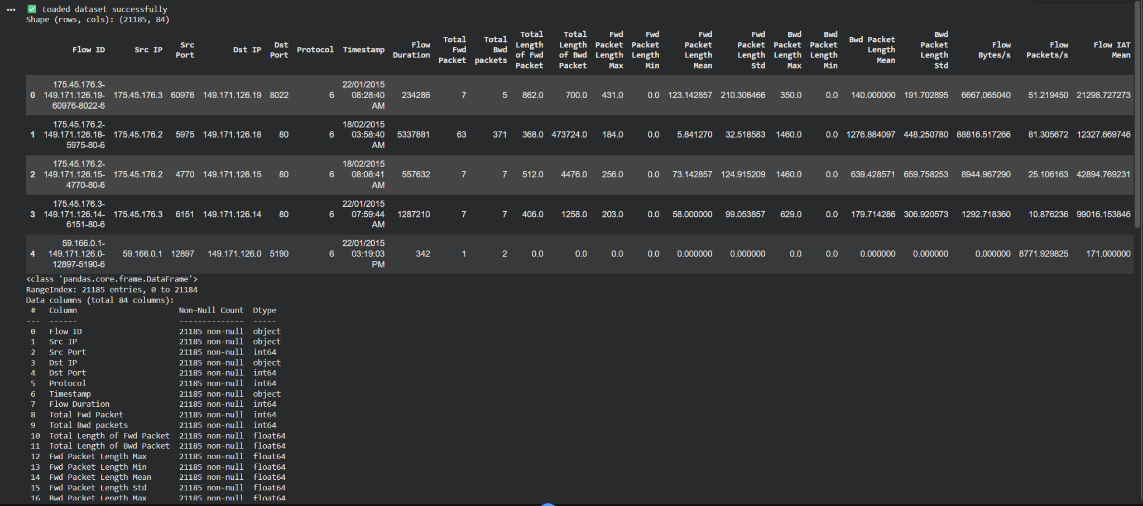
Figure 1: Dataset loaded successfully (head + column overview).
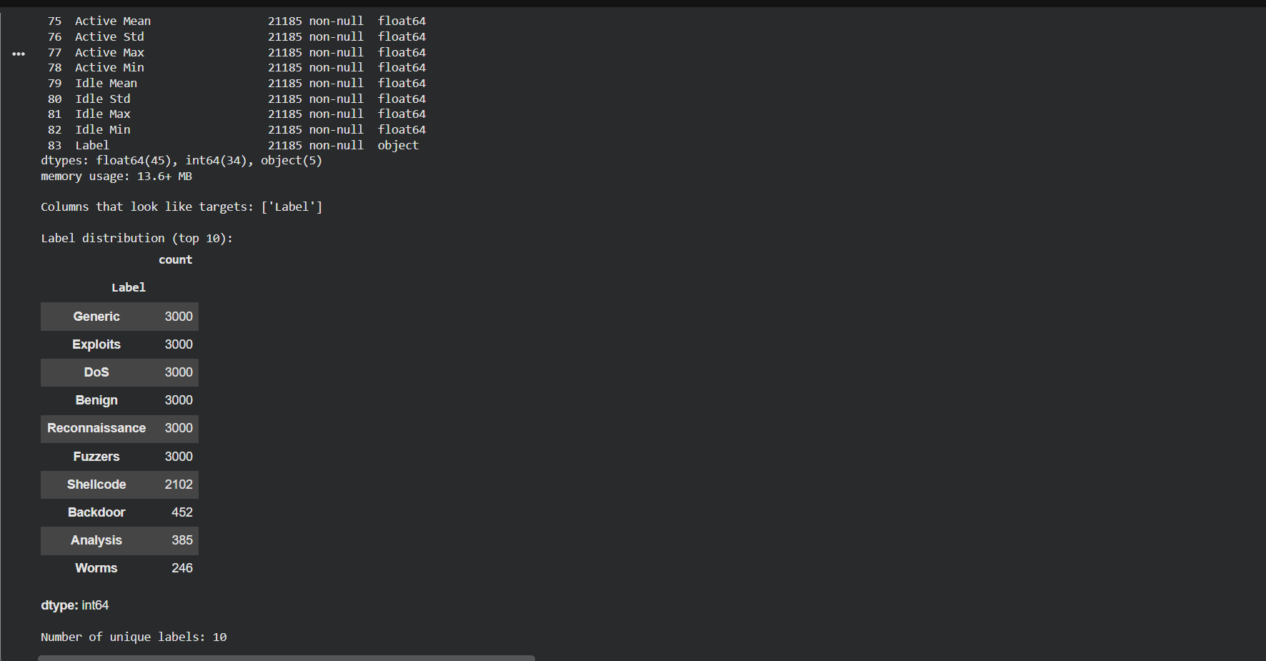
Figure 2: Target column identified (“Label”) and label distribution preview.

4. Data Preparation and Cleaning
Before modelling, we completed thorough data validation, verifying that:
• Check for missing values on a per-column basis yielded no results.
• Check for duplicate entries for each row yielded no duplicates.
• Check for infinite values showed (±∞) could not be located in any of the numeric columns.
• Check for a mixture of data types showed that numeric features were mixed in with identifier fields (Flow ID, IP address, and Timestamp) were as expected.

It is crucial to communicate these checks even after examining the dataset because the absence or infinity of entries may create an unforeseen failure or inconsistency during model training. In addition, we ensured to convert the Timestamp field into a valid datetime type to enable consistent extraction of time-based features.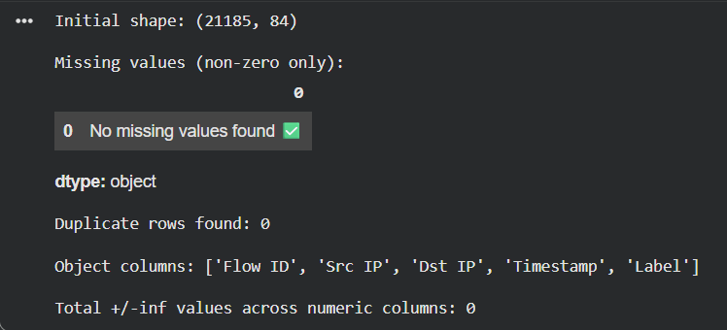
Figure 3: Data integrity checks (no missing values, no duplicates, no infinite values).
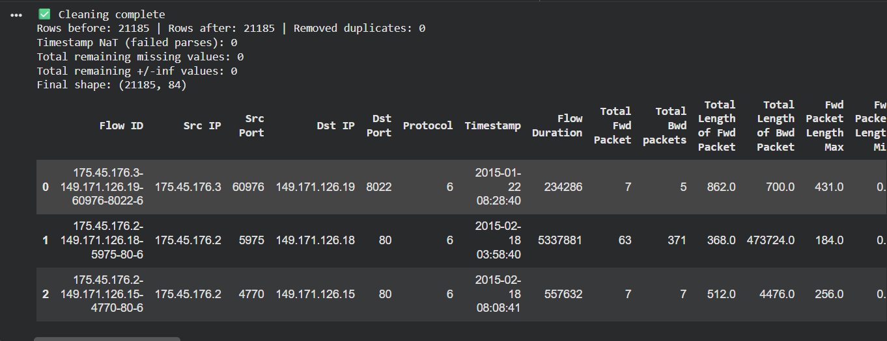
Figure 4: Cleaning summary and preview of cleaned dataframe.

5. Feature Engineering and Selection
Feature engineering focused on improving both predictive signal and interpretability.
5.1 Timestamp-derived features
The original dataset contained a Timestamp column stored as text. Instead of discarding time information, we extracted: ts_hour (0–23), ts_dayofweek (0=Mon … 6=Sun), and ts_month (1–12). After extraction, we dropped the raw Timestamp field to avoid mixing text with numeric inputs.
5.2 Dropping identifiers
We removed columns that act as identifiers rather than stable learning signals: Flow ID, Src IP, Dst IP. These identifiers can cause data leakage or memorisation and do not generalise to new traffic.
5.3 Numeric-only feature matrix and constant-feature removal
After converting and validating numeric types, we removed constant columns (features with only one unique value) because they do not contribute to classification and can add noise. In our dataset, 9 constant columns were removed, resulting in 73 numeric features used for modelling.
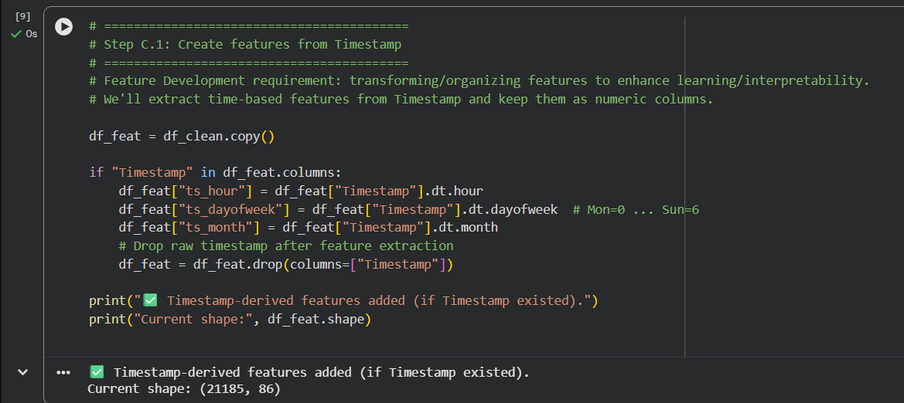
Figure 5: Timestamp feature extraction (ts_hour, ts_dayofweek, ts_month) and updated shape.
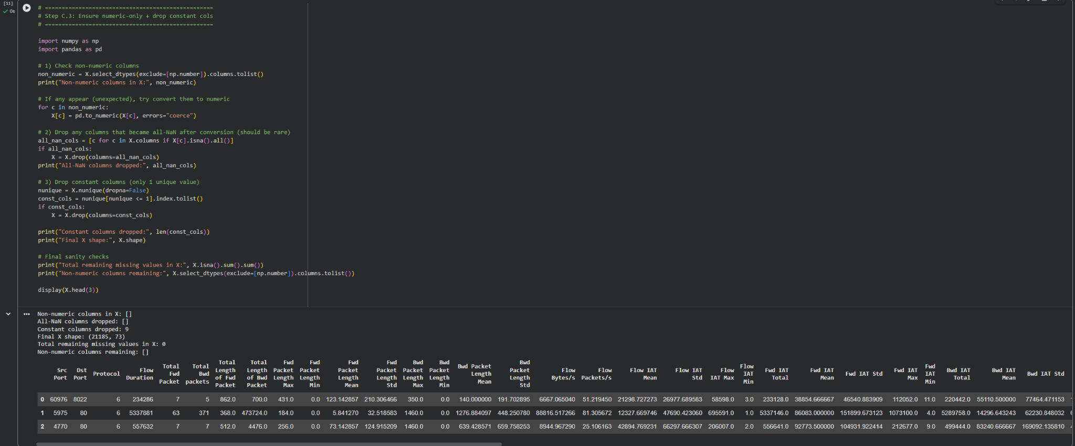
Figure 6: Numeric-only feature matrix creation and constant-column removal (final X shape = 21,185 × 73).

6. Supervised Learning Methods
We implemented and compared two supervised multi-class classifiers.
6.1 K-Nearest Neighbours (KNN)
KNN predicts the class of a new sample by voting among the labels of its K nearest training samples in feature space. Because KNN is distance-based, feature scaling is essential; therefore, we used StandardScaler inside a Pipeline. KNN is simple and non-parametric, but can struggle in high-dimensional spaces and is sensitive to irrelevant features.
6.2 Linear Support Vector Machine (Linear SVM)
A linear SVM learns separating hyperplanes that maximise margin. For multi-class classification, a one-vs-rest strategy is used. Linear SVMs often perform strongly on high-dimensional numeric data and can be more robust than KNN when features are numerous and correlated. We used LinearSVC with scaling for stable optimisation.
6.3 Train/test split and evaluation protocol
We used an 80/20 stratified split to preserve class distribution across train and test sets (16,948 training flows; 4,237 testing flows). We report accuracy and macro-averaged precision/recall/F1. Macro-averaging treats each class equally, which is important given minority classes such as Worms, Analysis, and Backdoor.
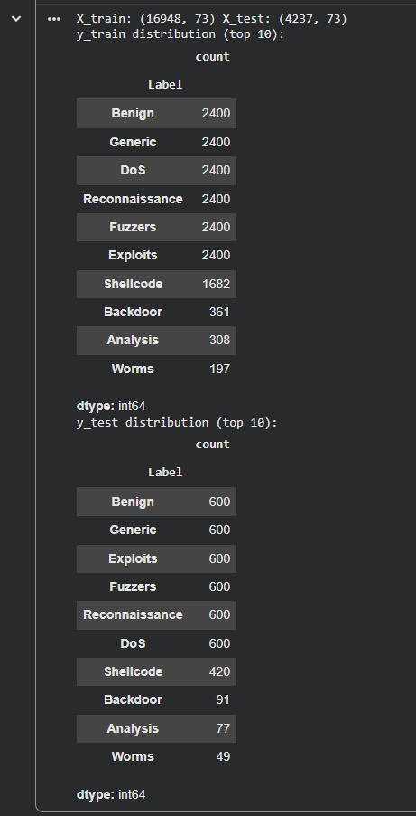
Figure 7: Stratified train/test split and class distribution in train vs test.
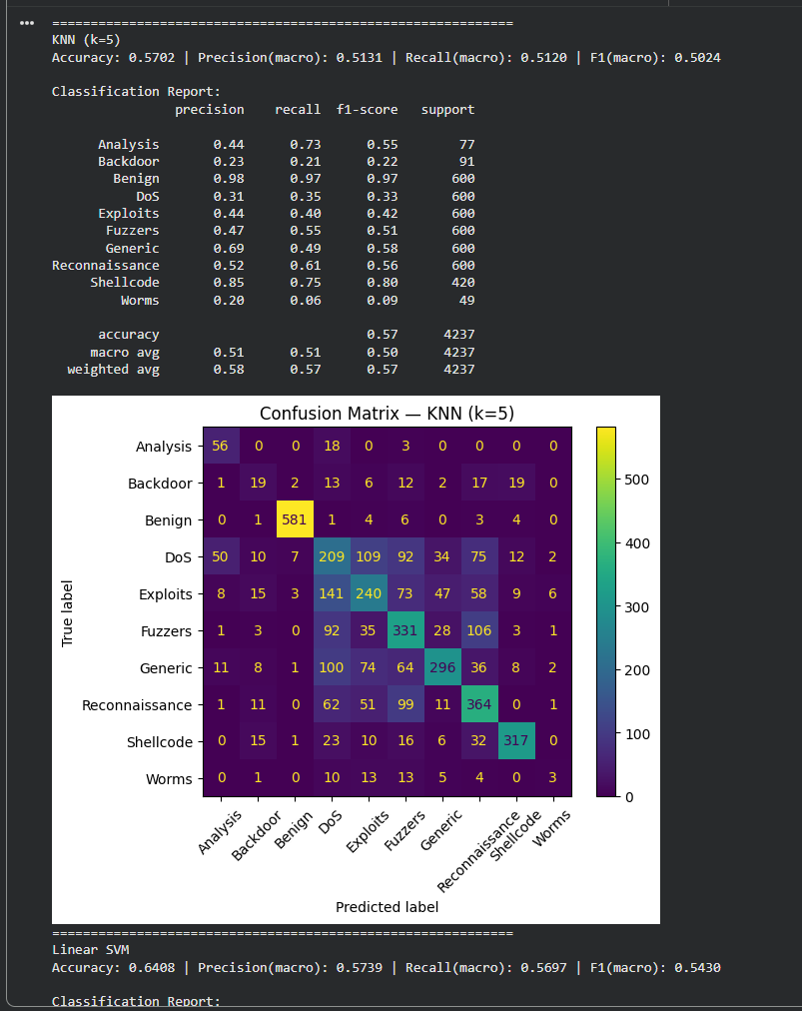
Figure 8: Baseline KNN (k=5) and Linear SVM results (classification reports + confusion matrices).

7. Hyperparameter Tuning and Model Selection
7.1 KNN tuning
We tuned K using 5-fold Stratified Cross-Validation on the training set. Candidate values were K ∈ {1, 3, 5, 7, 9, 11, 15} and the optimisation metric was macro-F1 to respect minority classes. The best CV macro-F1 occurred at K=9 (≈ 0.494).
7.2 Final supervised comparison
After tuning, KNN improved slightly on test accuracy (≈ 0.570 → ≈ 0.573), but macro-F1 remained around ≈ 0.504. Linear SVM remained the strongest overall model with ≈ 0.641 accuracy and ≈ 0.543 macro-F1. The improvement of SVM suggests that margin-based separation is more effective than local neighbourhood voting for this feature space.
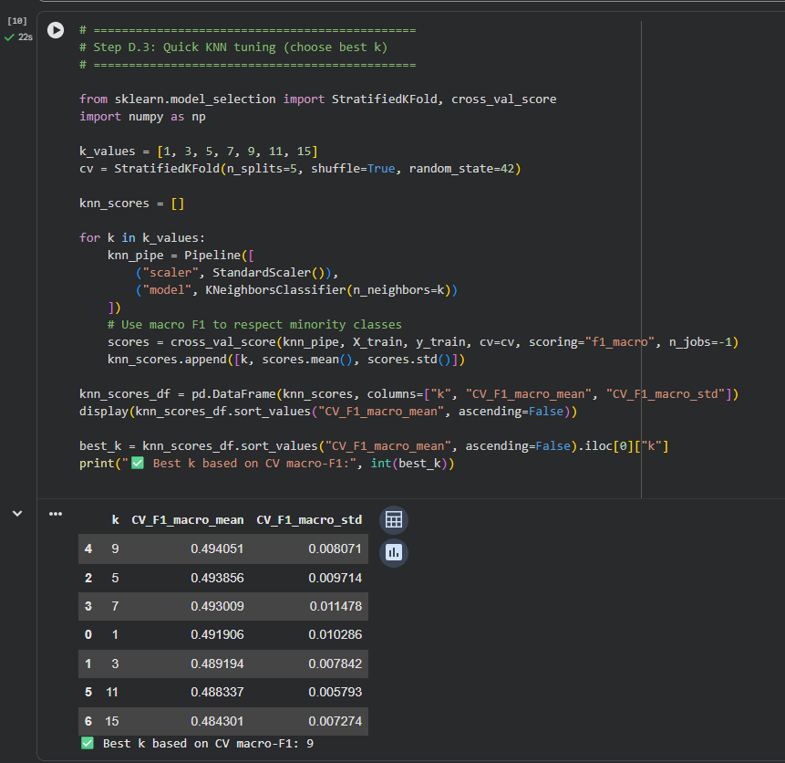
Figure 9: KNN cross-validation tuning results (best K=9 by macro-F1).
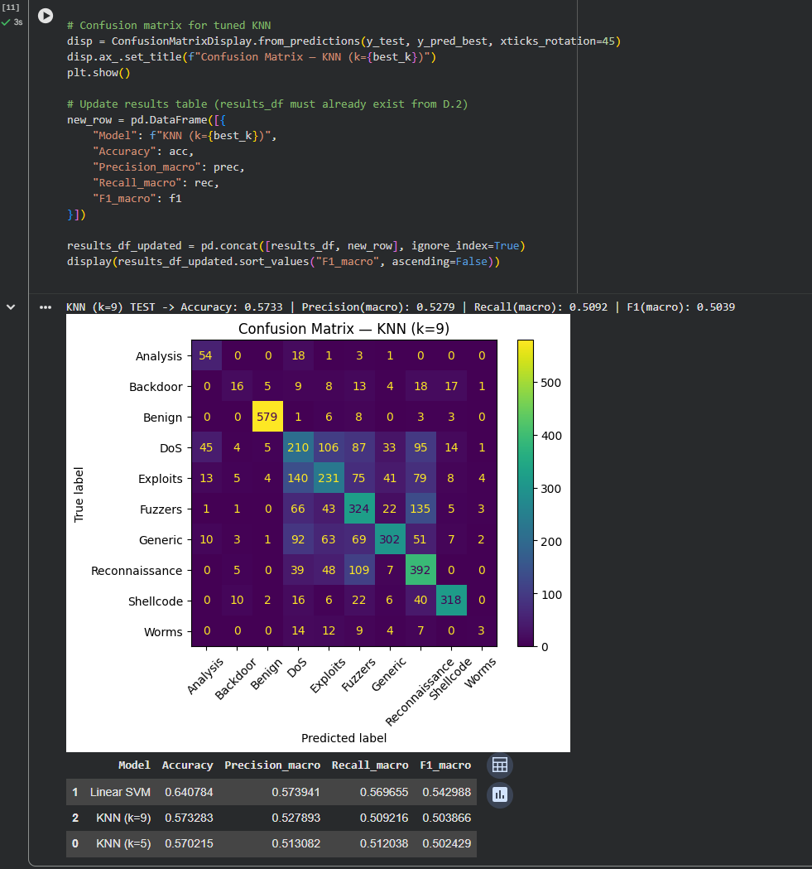
Figure 10: Tuned KNN (k=9) evaluation and updated model comparison table.
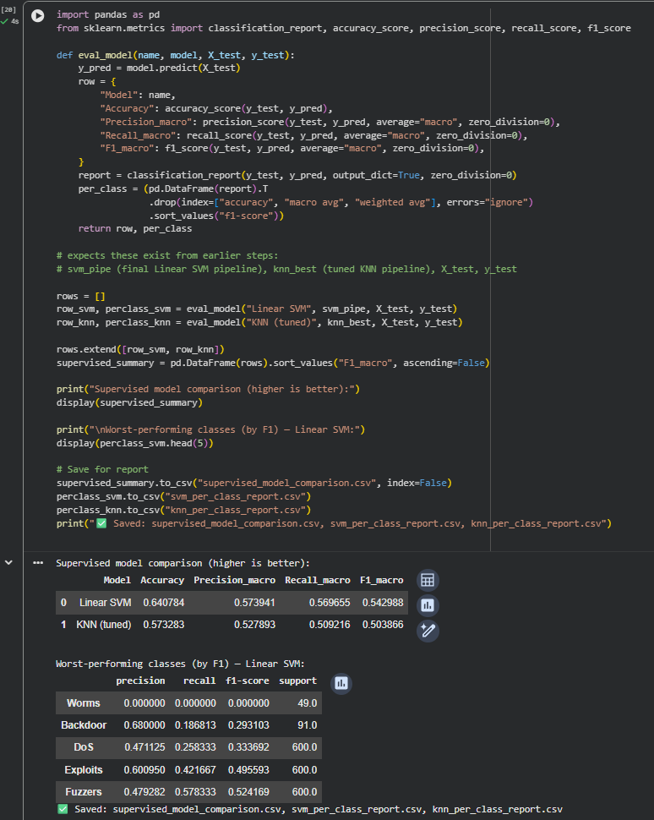
Figure 11: Supervised model comparison and worst-performing classes (by F1).

7.3 Summary table (test set)
Model | Accuracy | Macro Precision | Macro Recall | Macro F1
KNN (k=5) | 0.5702 | 0.5131 | 0.5120 | 0.5024
KNN (k=9 tuned) | 0.5733 | 0.5279 | 0.5092 | 0.5039
Linear SVM | 0.6408 | 0.5739 | 0.5697 | 0.5430
Interpretation: Linear SVM provides the best balance across classes according to macro metrics. KNN performs strongly for Benign traffic but struggles to separate multiple attack categories that overlap in flow statistics, especially when minority classes are present.

8. Unsupervised Anomaly Detection (Isolation Forest)
Supervised classifiers rely on known labels. To complement them, we applied Isolation Forest (IF) to the numeric feature space to flag unusual flows. Isolation Forest isolates anomalies by randomly partitioning the feature space; points that require fewer splits to isolate are considered more anomalous.
8.1 Contamination (expected anomaly rate)
Because we do not have ground-truth anomaly labels, we set contamination = 0.05 (flag the most unusual 5% of flows). This provides a practical threshold that is easy to interpret and aligns with triage-style anomaly detection where analysts review the top-ranked outliers.
8.2 Outputs
Isolation Forest marked 1,060 flows as anomalous (≈ 5.00% of the dataset). We analysed the distribution of known labels among flagged anomalies and ranked flows by anomaly score to identify the most extreme outliers.
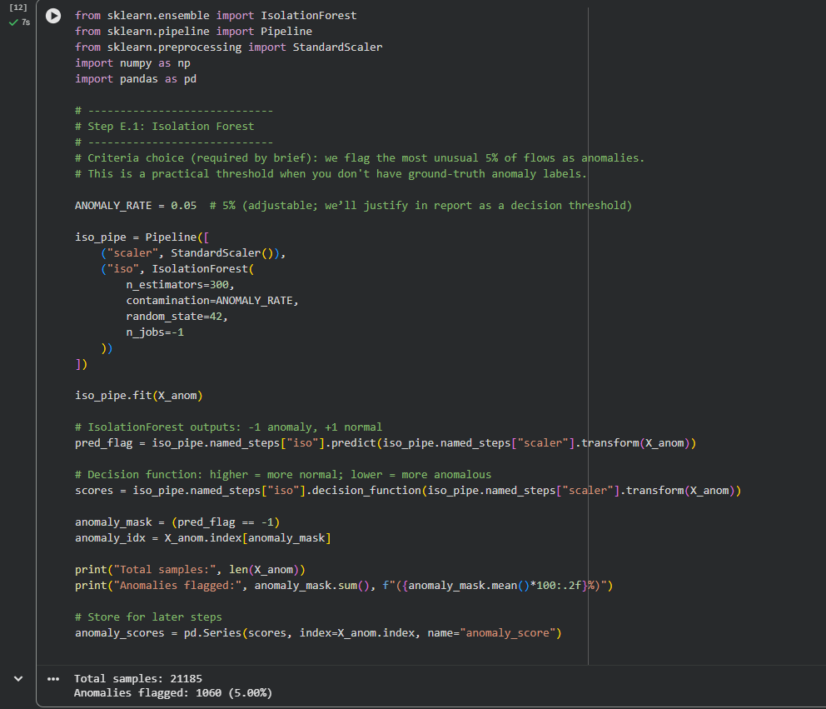
Figure 12: Isolation Forest configuration and anomaly rate (5% flagged).
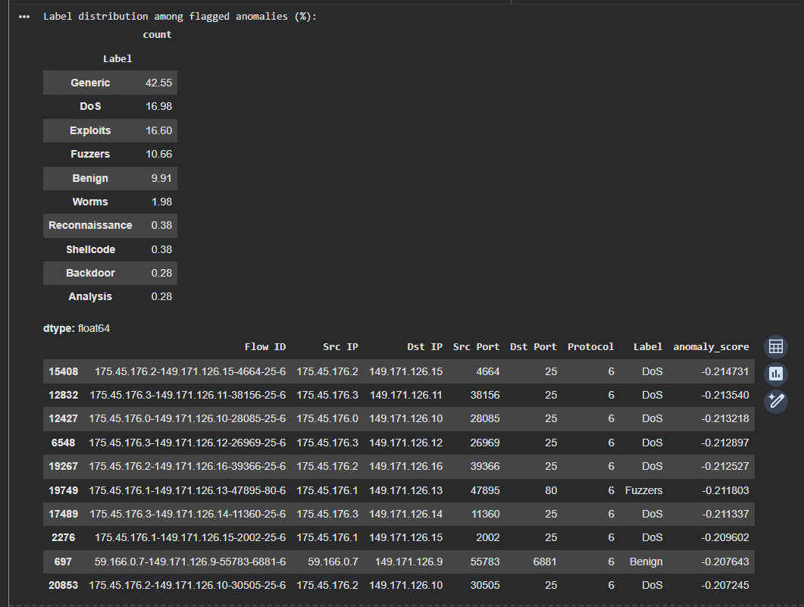
Figure 13: Label distribution among flagged anomalies and example anomalous flows with scores.
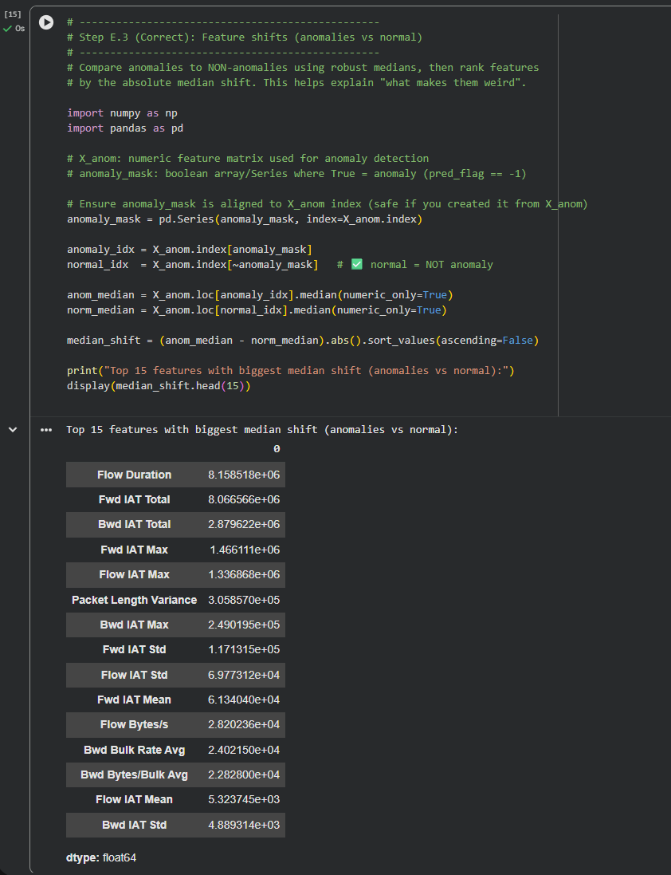
Figure 14: Feature median shifts (anomalies vs non-anomalies): top features by absolute shift.
Key observation: A large share of flagged anomalies belong to the “Generic” class (~42.55%), followed by DoS and Exploits. However, a non-trivial portion of anomalies are labelled “Benign” (~9.91%), which is expected: benign traffic can contain rare events that are statistically unusual but not malicious. In real operations, anomaly detection is best used as a triage tool rather than a definitive classifier.

9. Interpretation and Feature Analysis
Understanding why a model predicts a given class is important in cybersecurity. We used two complementary interpretability methods for the best supervised model (Linear SVM).
9.1 Coefficient-based global importance
Linear SVM provides per-class linear weights for each feature. We computed a global importance score by taking the mean absolute coefficient across classes. This highlights which inputs generally influence the decision boundaries.
9.2 Permutation importance
Permutation importance measures how much performance drops when we randomly shuffle a feature, breaking its relationship to the label. We computed macro-F1 permutation importance on a test subset for computational efficiency. This provides a model-agnostic check and helps validate whether coefficient ranking aligns with predictive usefulness.
9.3 Per-class drivers
We extracted top positive and negative coefficients per class to identify features that push predictions toward or away from each threat type.
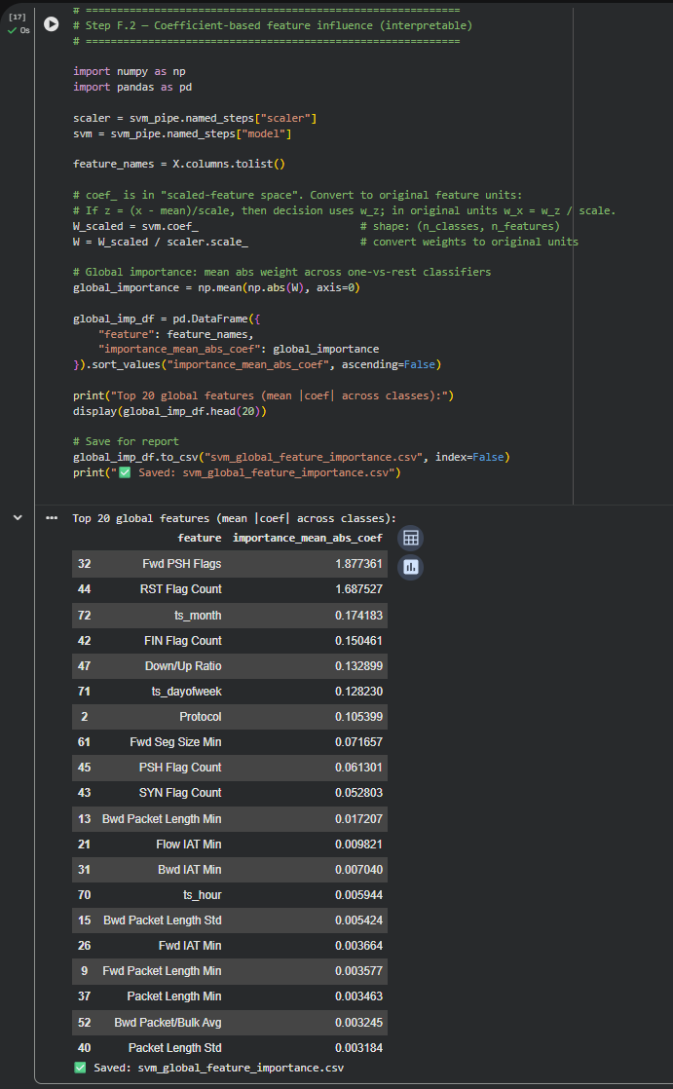
Figure 15: Coefficient-based global feature importance (mean |coef| across classes).
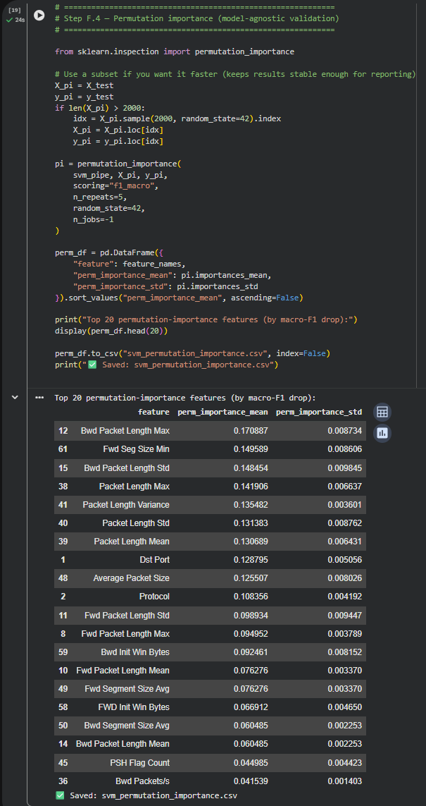
Figure 16: Permutation importance (macro-F1 drop) for top features.
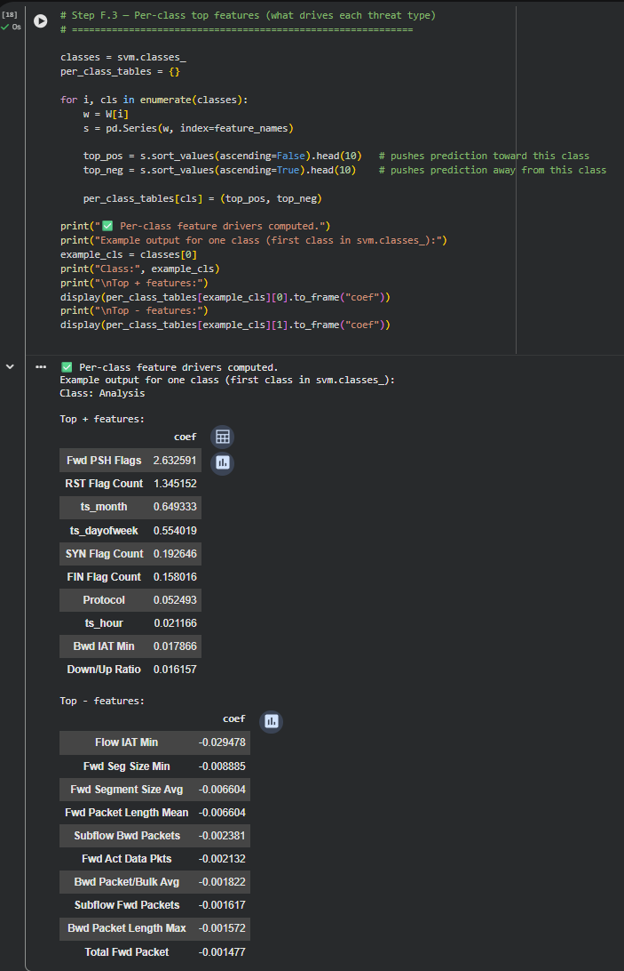
Figure 17: Example per-class feature drivers (positive and negative coefficients for one class).
Interpretation summary:
• TCP flag count features (e.g., PSH, RST, FIN, SYN) appear as strong drivers, which is plausible because different attack behaviours have characteristic flag patterns.
• Packet length statistics and segment sizes are consistently important, reflecting traffic volume and burst patterns.
• Destination port and protocol are also influential (permutation ranking), consistent with attacks targeting specific services.
• Time-derived features (ts_month, ts_dayofweek) appear in coefficient rankings, suggesting temporal structure in the capture period; these may not generalise across different capture windows and should be treated cautiously.

10. Discussion: Implications, Challenges, Limitations, Improvements
10.1 Practical implications
Our best supervised model (Linear SVM) can be used as a first-pass classifier to label incoming flows as Benign or as specific attack categories, enabling automated alert routing and prioritisation. In parallel, Isolation Forest can rank unusual flows for review, which is useful for identifying novel patterns not covered by known labels.
10.2 Challenges encountered
• High dimensionality (73 numeric features) increases the chance of overlapping classes and noisy distances for KNN.
• Minority classes (Worms, Analysis, Backdoor) reduce macro-F1 and are difficult to learn reliably. In our results, Worms had near-zero F1 in Linear SVM, indicating almost no correct predictions for that class.
• Several attack types show similar flow-level signatures, leading to confusion in the confusion matrices.
10.3 Limitations
• Evaluation uses a single hold-out split; repeated splits or nested CV would provide stronger confidence.
• Temporal features may encode capture-specific artefacts that limit generalisation.
• Isolation Forest anomalies are statistical outliers and may include benign rare events.
10.4 Possible improvements
• Hyperparameter optimisation for SVM (C tuning) and considering kernels if feasible.
• Class-weighting or resampling to improve minority-class recall.
• Feature selection/dimensionality reduction to reduce noise for distance-based methods.
• Probability calibration and thresholding for operational deployment.
• Local explanations (e.g., SHAP) for case-by-case interpretability if allowed.

11. Overall Findings and Final Reflections
Our experiments show that a linear margin-based classifier (Linear SVM) provides better multi-class classification performance than KNN on this cyber flow dataset, especially when judged by macro-averaged metrics that treat all classes fairly. KNN benefited from tuning but improvements were modest, suggesting that local neighbourhood structure is not sufficiently clean in the chosen feature representation.
The unsupervised anomaly analysis adds a second lens: anomaly detection highlights statistically unusual flows, which is useful where labels are incomplete or adversaries evolve tactics. The most anomalous flows were associated with strong shifts in duration and inter-arrival-time features, indicating atypical timing/burst patterns.
This project reinforced the end-to-end ML workflow: validate data, engineer features, build baselines, tune, evaluate with appropriate metrics, and interpret the outcome in the domain context.

References
- IT7009 – Practical Project Brief 1 (unit-provided assessment document).
- IT7009 lecture materials (Weeks 1–11), focusing on supervised classification, evaluation metrics, and data preparation.

Appendix A: Reproducibility and Saved Artefacts
During execution, we saved intermediate artefacts for reporting and verification, including: svm_global_feature_importance.csv, svm_permutation_importance.csv, supervised_model_comparison.csv, svm_per_class_report.csv, knn_per_class_report.csv, anomaly_label_distribution_pct.csv, anomaly_rate_by_label.csv, and top200_anomalies.csv. We also ran a final QA checklist to confirm shapes, absence of missing values, and presence of expected outputs.
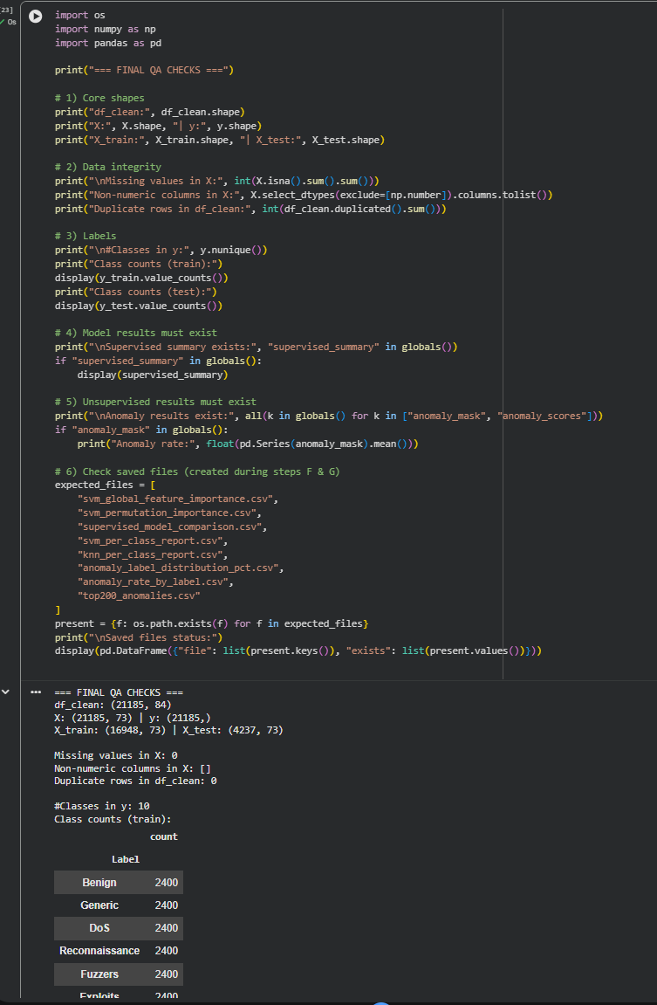
Figure A1: Final QA checks confirming dataset integrity and saved artefacts.
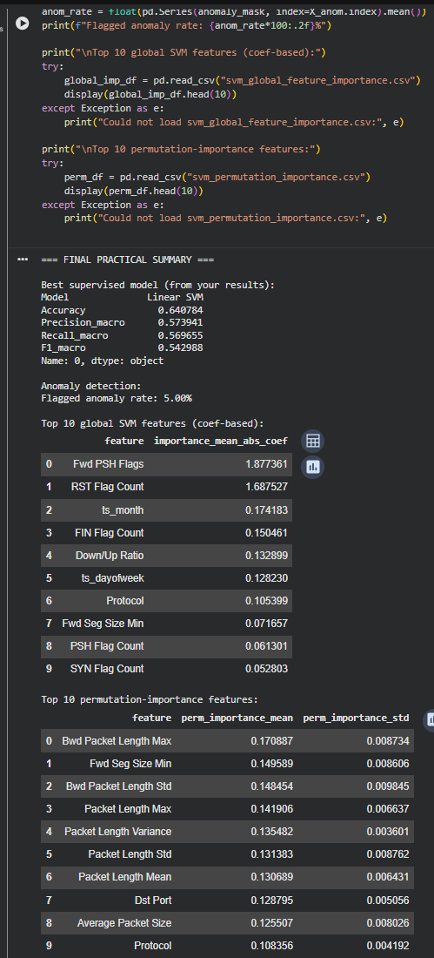
Figure A2: Final practical summary (best model, anomaly rate, top features).

